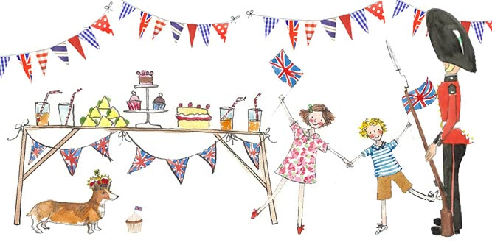
We are having a party for the
Queen’s Platinum Jubilee
at Nursery on Thursday 26th May.
Children are welcome to come wearing anything red,
white or blue, or in party clothes.

We look forward to celebrating this very special event with the children!

